**AIRLINE RESERVATION SYSTEM UML DIAGRAMS**

**R.Rithvik roshan**

**192124021**

**1.USE CASE DIAGRAM**

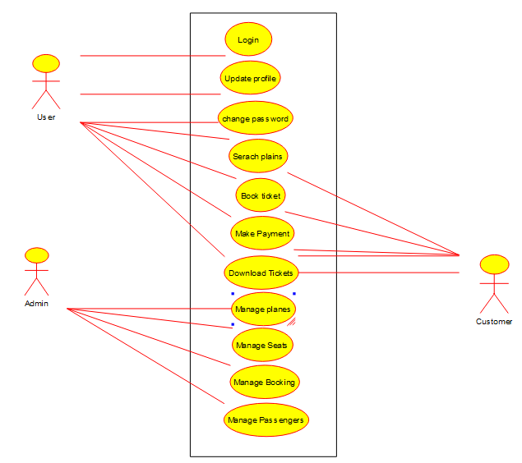

**2.SEQUENCE DIAGRAM**

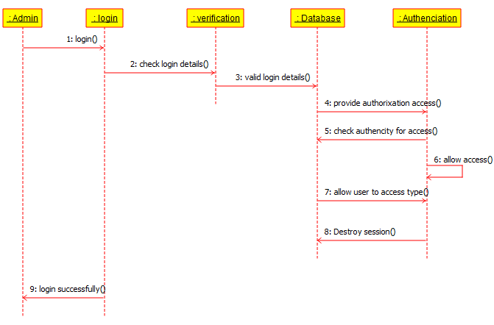

**3.CLASS DIAGRAM**

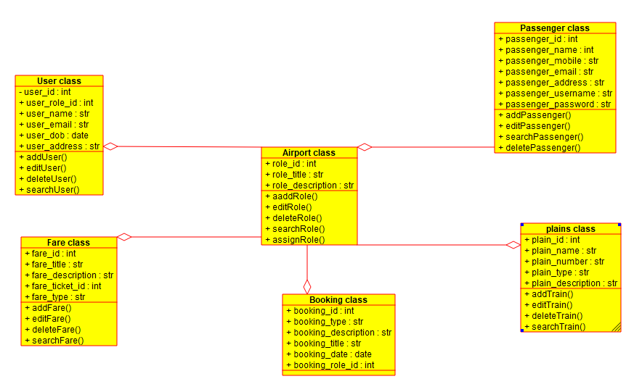

**ACTIVITY DIAGRAM**

